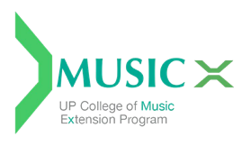

Wala ka bang magamit na gadget para sa online classes?
Apply for an FCCP Computer Grant through the Music X Office. Available gadgets for loaning on a semestral basis are Google Chrome books. All you need is fill-up an application form — available upon request at the Music X Office (sdsison@up.edu.ph) — and submit on or before September 23, 2022. Applications will be evaluated by the UPCMu Scholarship Committee at its meeting on September 26, 2022.

Recipients of the FCCP Computer Grant are expected to:
- collect the Chromebook from the College of Music and sign the contract of loan;
- use the Chromebook for class purposes only;
- not let someone else use it;
- return the Chromebook to the Music X Office in
good working condition at the end of the semester;
- shoulder any expenses for repairs (in case of damage); and
- pay the cost of the gadget (in case of loss).

